**Jahangirnagar University**

**Department of Computer Science & Engineering**



**Course Code**: CSE-402

**Course Title**: Computer Networking Laboratory

**Submitted by**:

**Name**: Md Shamim Imtiaz

**Roll No**: 47

**Date of Submission**: 17th October, 2019

**Experiment No: 05**

**Experiment Name:** Configuration of DNS server

**Objective:**

We will simulate a network with two DNS server under different network connected via a router and check whether pc in different network can connect to a DNS server written by its name.

**Description:**

use easy-to-remember domain names for websites instead of their numeric IP addresses. For example, the domain name www.email-freeplan.com might be translated to 198.105.232.47. The data that tells the web server how to respond to your input is known as the DNS records or zone files. These records play a significant role in the functionality of the internet.

DNS syntax is a set of commands that dictate the actions of the DNS server. The most used records stored in the DNS database are IP addresses like A and AAAA; domain name aliases like CNAME; SMTP mail exchangers like MX; pointers for reverse DNS lookups like PTR; and name servers like NS or Start of Authority (SOA).

**DNS:**

DNS ( domain name server ) or Domain Name System translates domain names into IP addresses. Domain names are easier to remember, but the internet is based on IP addresses. Every website has an IP address that is its internet location. DNS (Domain Name System) is the largest database of information about every website on the internet.

**Simulation:**

1. **2 Server and 1 Router:**

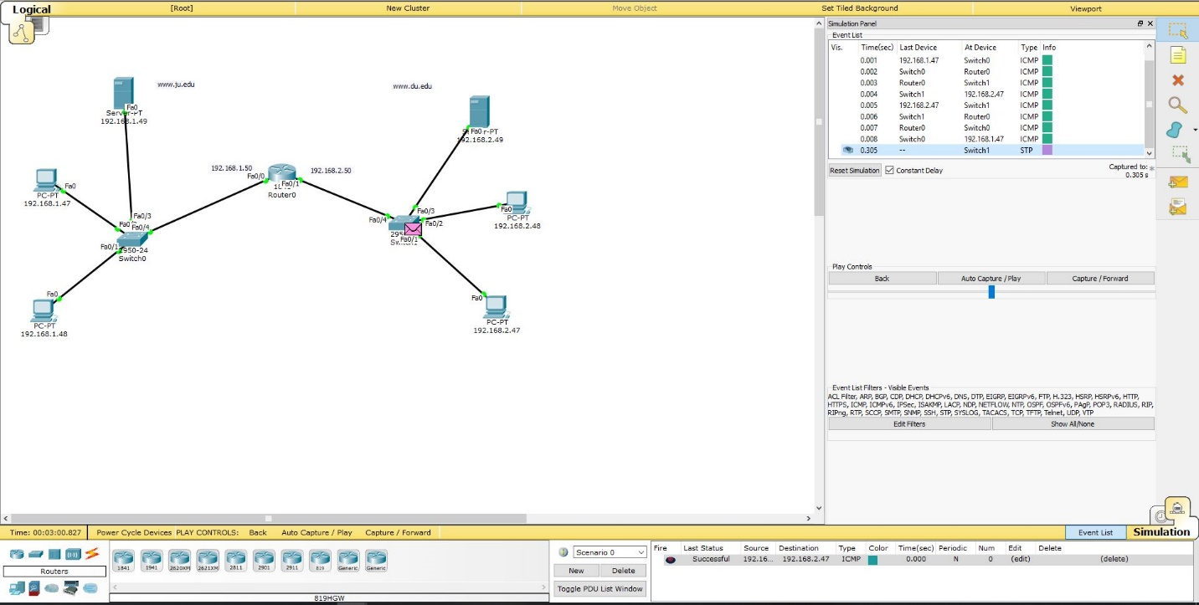

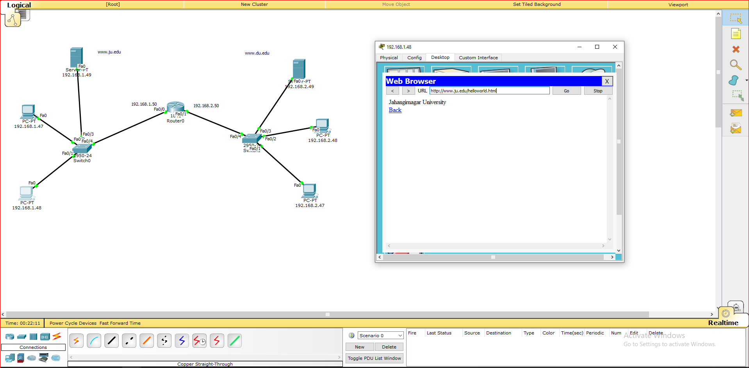

1. **2 Server and 2 Router:**

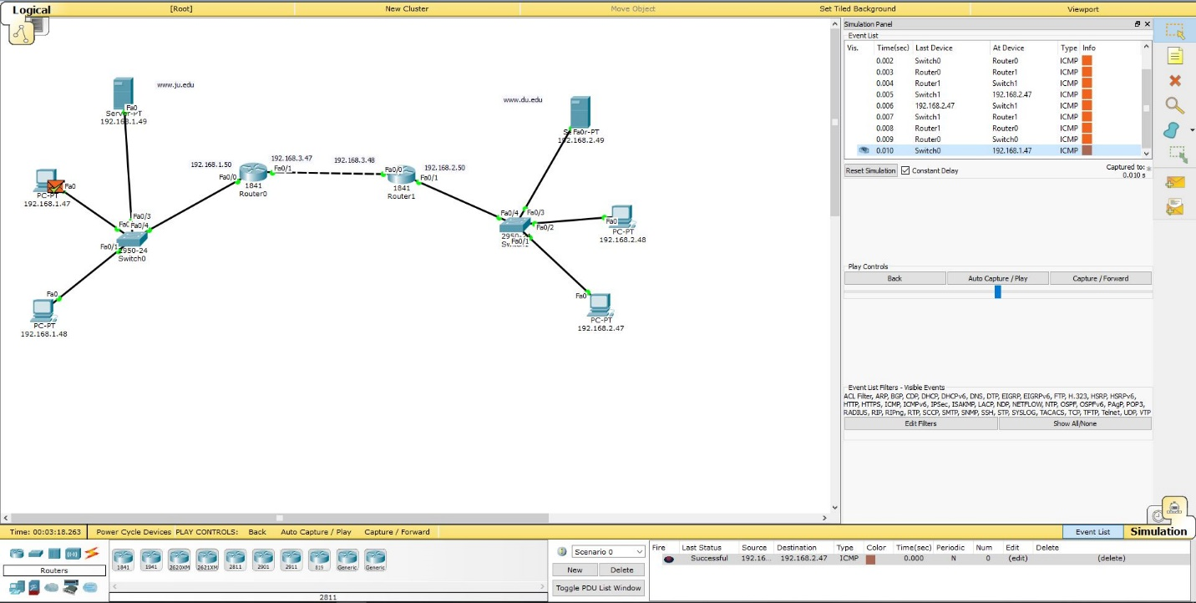

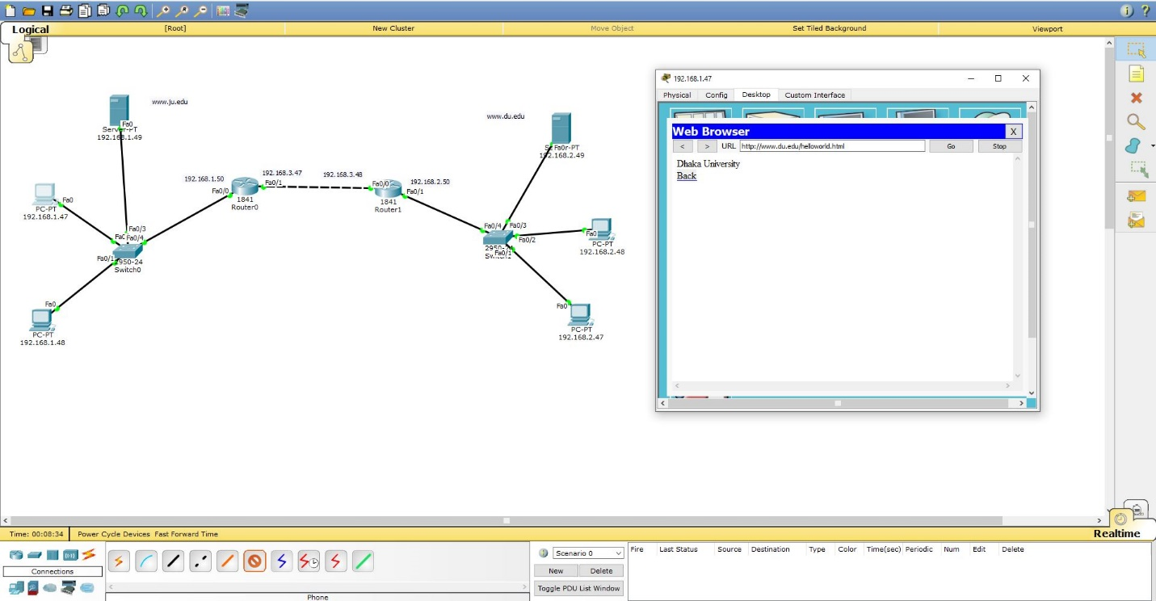

**DNS service configuration:**

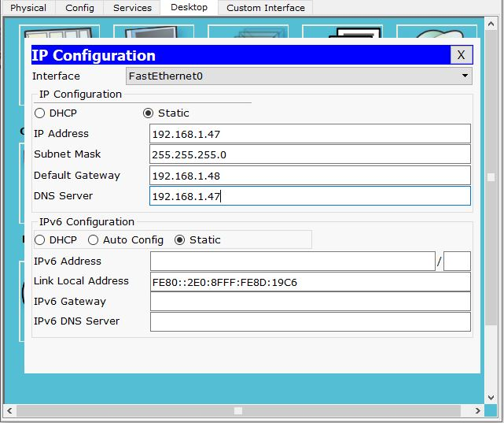 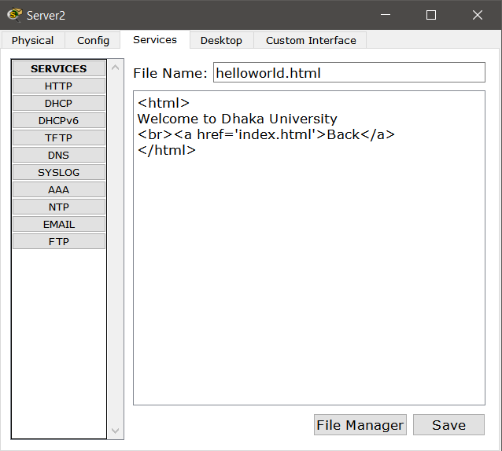

**Discussion:**

We can see that the Routers sends the packet the required path mentioned in the rout table. People tend to get benefit from a router for through a packet to a different network. A router is better for connecting different network. After using router we can easily use hub, switch, PC for any other connection and for any other communication. We can clearly observe that Instead of typing the actual IP address we can access this particular page via its Domain Name. So the experiment is valid.